**1)NUMBER OF CALLS REGISTERED BY FIRE DEPARTMENT OVER THE SPAN OF 5 YEARS**

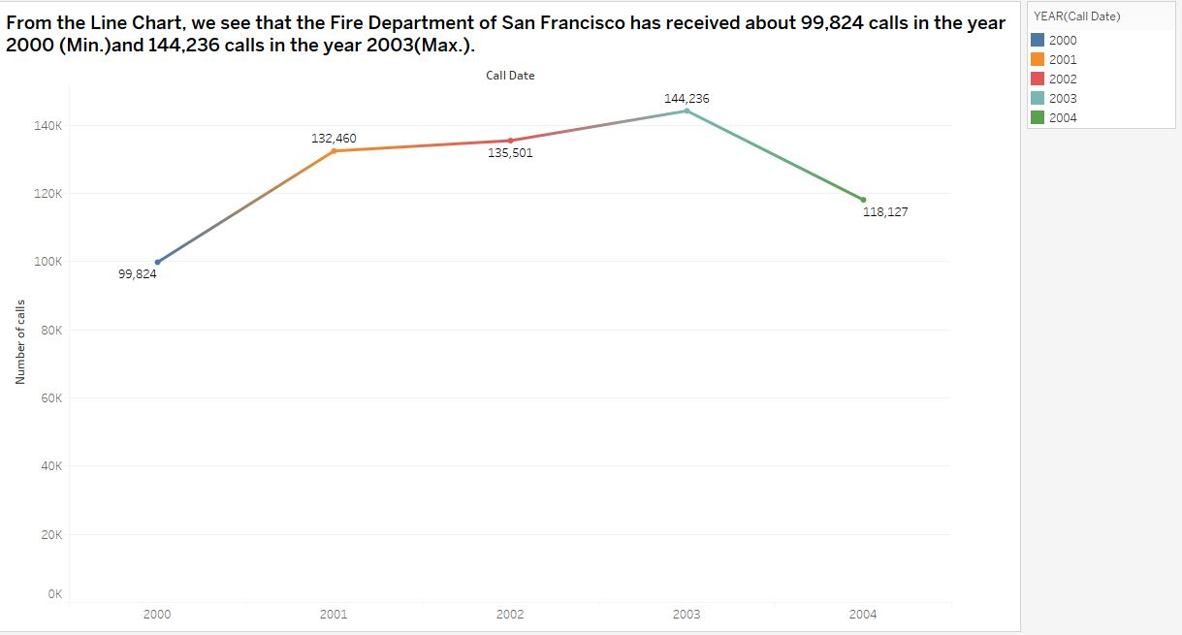

* **In the above given visualization, we have tried to monitor the number of calls registered in the period of more than 05 years**
* **The rows and column are the year of the calls registered and number of calls recorded in that particular year**
* **From the above visualization, we see State of San Francisco received maximum call i.e. 144,236 in the year 2003**

**2)THE NUMBER OF UNITS DISPATCHED ACCORDING TO THE DIFFERENT TYPES OF CALLS REGISTERED**

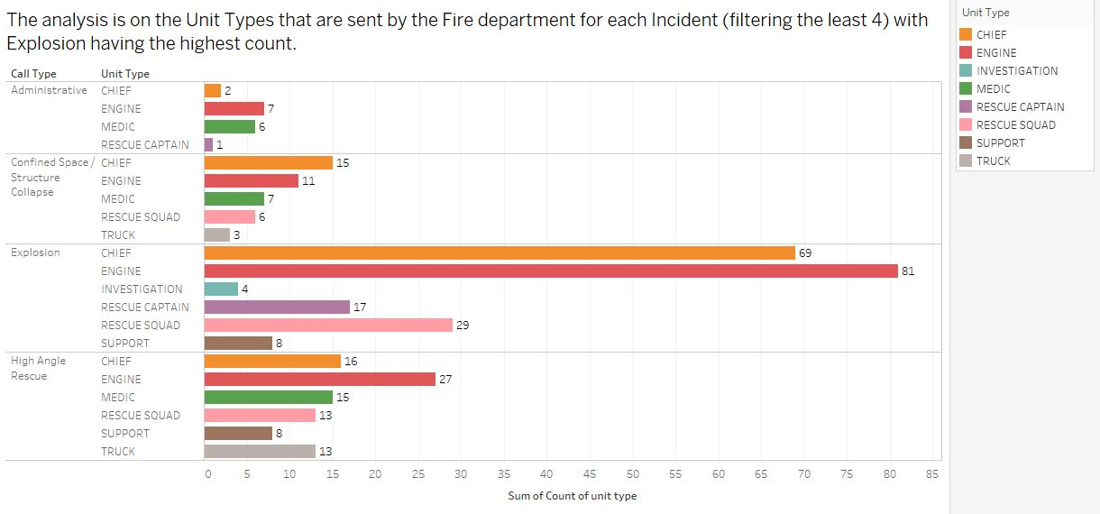

* **From the next visualization, we try to look at the number of Units dispatched with respect to each unique incident recorded in the particular neighborhood in San Francisco**
* **The columns are the Call and Unit types while the Rows are the count of the different unit types dispatched**
* **For instance, Explosives are the major type of Incident calls for which maximum no of Unit type i.e. Engine has been sent to the site**

**3)NUMBER OF INCIDENTS LABELLED BY ZIP CODES USING GEO SPATIAL**

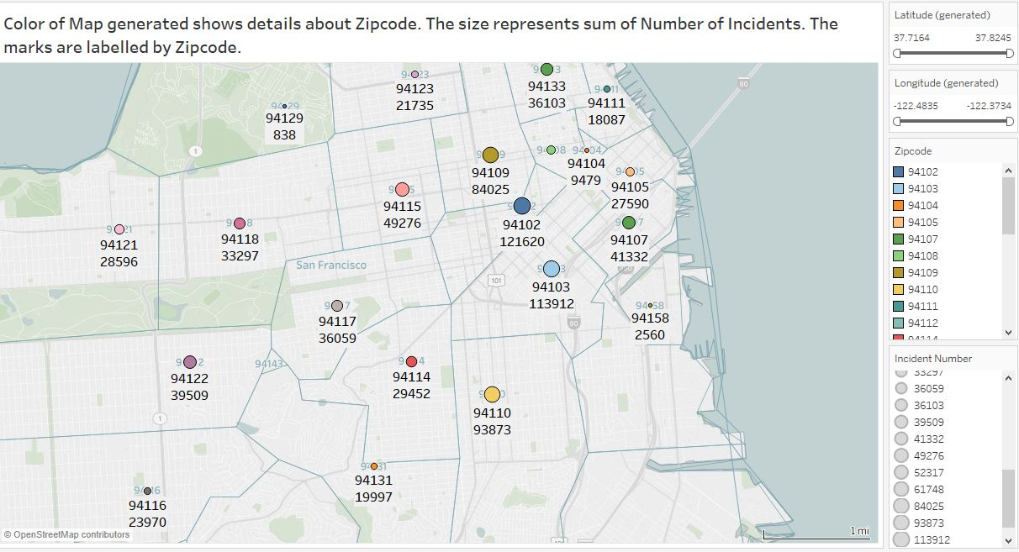

* **In the above given Geo-Spatial visualization, we have generated a color map showing details of the Zip code in San Francisco**
* **The unique number like 94129 are assigned to the Zip code. Further we have also tried to show the count of Incidents pertaining to the particular zip code**
* **The size represents the count i.e. the more the number of Incidents bigger is the size**
* **Like 94102 zip code area recorded highest number of Incidents i.e. 121,620**

**4)ANALYSIS OF INCIDENTS OVER THE PERIOD OF FIVE YEARS**

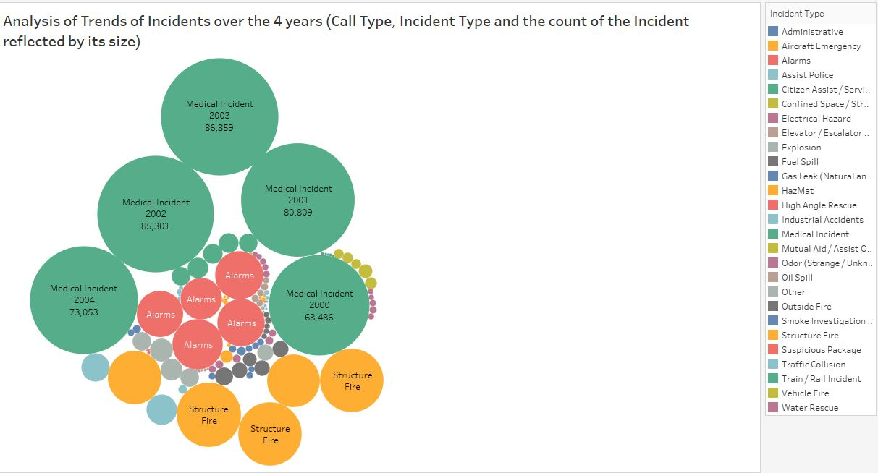

* **The Packed Bubbles chart clearly states that from the year 2000 to 2004 the fire department received calls majorly for three issues, Medical Incidents leading the list.**

**5)CALL TYPES CATEGORIZED ACCORDING TO LOW AND HIGH PRIORITIES**

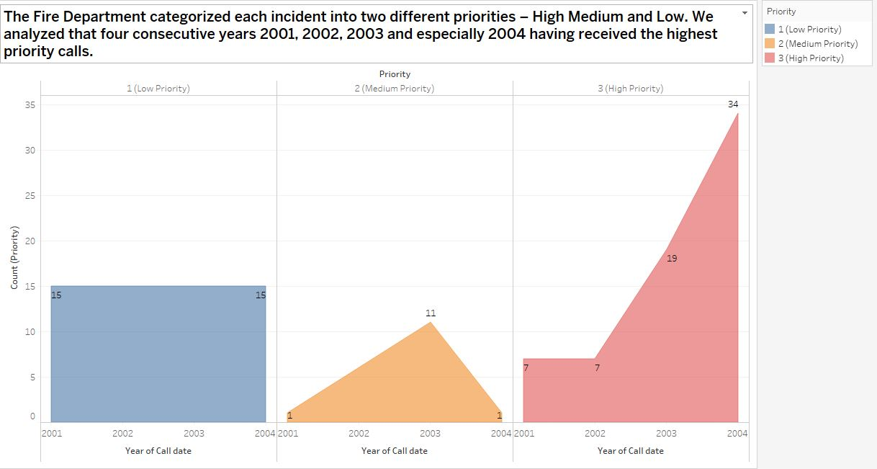

* **According to our dataset, we have tried to categorize calls according to the levels of priorities**
* **1 represents low priority, 2 means medium and 3 means High priority**
* **The rows and columns are stacked against each other as year of Call date and Call priority**
* **The color also signifies the varied levels of Priority**

**6) This is the step to step analysis the count of call types according to neighborhood**

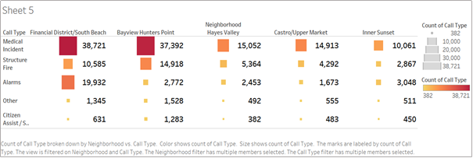

* **In the above visualization, we have done analysis with no of call types with respect to the neighborhood areas**
* **For the above given visualization, the columns represent the call types, while the row depicts the different areas of San Francisco**
* **The Range of the call types are portrayed using light to dark colors. The lightest color represent low no of call type i.e. 382(Citizen Assist for Neighborhood Hayes valley) while the dark red is for the highest no call registered i.e. 38,721 (Medical Incident for South Beach area)**